Youwei Zhang

# Code

Excellent work!

9.5/10

# Testing

Very good!

4/4

/* File: preprocessor.c

* Author: Youwei Zhang

* School: Dalhousie University

* Dept: Electrical and Computer Engineering

* Course: ECED 3403 Computer Architecture

*

* Purpose： This file is the preprocessor that translates legacy XM2 instructions into

* XM3 instructions, then output an XM3 and report all error

* Last Modified: 2020.5.30

*/

#include <stdio.h>

#include <stdlib.h>

#include <string.h>

#include <ctype.h>

#define RECORDLENGTH 255

#define TOKENLENGTH 15

#define TABLECONVERTS 35



#define TABLECOLUMN 4

#define NOMORE "XXXNOMORE"

enum

{

NOEXIST = -3,

COMMTKN = -2,

NOMATCH = -1,

ONE_INST = 0,

TWO_INST = 1,



INST_OPER = 2,

INST_LHOPER = 3,

INST_RHOPER = 4

};

struct Convert_Struct

{

char _legacy_inst[TOKENLENGTH];

int _type;

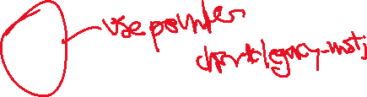

char _new_inst[TOKENLENGTH];

char _new_oper[TOKENLENGTH];

};

struct Convert_Struct convert_table[TABLECONVERTS] = {

{"SPL0", ONE_INST, "SETPRI", "#0"}, {"SPL1", ONE_INST, "SETPRI", "#2"}, {"SPL2", ONE_INST, "SETPRI", "#3"}, {"SPL3", ONE_INST, "SETPRI", "#3"}, {"SPL4", ONE_INST, "SETPRI", "#4"}, {"SPL5", ONE_INST, "SETPRI", "#5"}, {"SPL6", ONE_INST, "SETPRI", "#6"}, {"SPL7", ONE_INST, "SETPRI", "#7"}, {"CLC", ONE_INST, "CLRCC", "C"}, {"CLN", ONE_INST, "CLRCC", "N"}, {"CLZ", ONE_INST, "CLRCC", "Z"}, {"CLV", ONE_INST, "CLRCC", "V"}, {"SEC", ONE_INST, "SETCC", "C"}, {"SEN", ONE_INST, "SETCC", "N"}, {"SEZ", ONE_INST, "SETCC", "Z"}, {"SEV", ONE_INST, "SETCC", "V"}, {"RET", ONE_INST, "MOV", "R5,R7"}, {"BEQ", TWO_INST, "CEX", "EQ,#1,#0"}, {"BZ", TWO_INST, "CEX", "EQ,#1,#0"}, {"BNE", TWO_INST, "CEX", "NE,#1#0"}, {"BNZ", TWO_INST, "CEX", "NE,#1,#0"}, {"BGE", TWO_INST, "CEX", "GE,#1,#0"}, {"BLT", TWO_INST, "CEX", "LT,#1,#0"}, {"BC", TWO_INST, "CEX", "CS,#1,#0"}, {"BNC", TWO_INST, "CEX", "CC,#1,#0"}, {"BN", TWO_INST, "CEX", "MI,#1,#0"}, {"CALL", INST_OPER, "BL", NOMORE}, {"PUSH", INST_LHOPER, "ST", "-R6"}, {"JUMP", INST_LHOPER, "MOV", "R7"}, {"PULL", INST_RHOPER, "LD", "R6+"}, {"CLR.B", INST_RHOPER, "MOVL", "#0"}, {"CLR", INST_RHOPER, "MOVLZ", "#0"}, {"CLR.W", INST_RHOPER, "MOVLZ", "#0"}, {NOMORE, NOMATCH, NOMORE, NOMORE}};

void Translate(FILE *xm3, int legacy_num, char *oper_token);



int XM2Check(char token[]);

int main(int argc, char **argv)

{

if (argc != 2)

{

printf("Invalid Input, please try again\n");



return 0;

}

FILE *xm3 = fopen("solution.asm", "w+");

FILE *xm2 = fopen(argv[1], "r");

char record[RECORDLENGTH];

char delimit[]=" \t\r\n\v\f";

while (fgets(record, sizeof record, xm2) != NULL)

{ // READ record from XM-2 input file

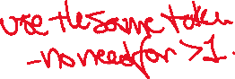

char *first_token = strtok(record, delimit);

int legacy_num = XM2Check(first_token);



if (legacy_num > NOMATCH)

{ //If first token is INST Token



char *second_token = strtok(NULL, delimit);

Translate(xm3, legacy_num, second_token ? second_token : NOMORE);

}

else if (legacy_num == NOMATCH)

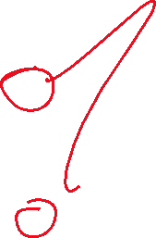

{



fprintf(xm3, "%s ", first_token);

char *second_token = strtok(NULL, delimit);

legacy_num = XM2Check(second_token);

if (legacy_num > NOMATCH)

{ //If second token is INST token

char *third_token = strtok(NULL, delimit);

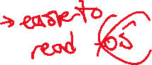

Translate(xm3, legacy_num, third_token ? third_token : NOMORE);

}

else if (legacy_num > NOEXIST) //Avoid (NULL) in solution file

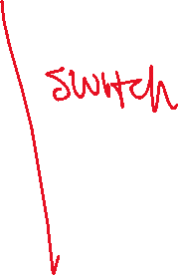

fprintf(xm3, "%s", second_token);

}

else if (legacy_num == COMMTKN)

fprintf(xm3, "%s", first_token);

char *token = strtok(NULL, delimit);

while (token != NULL)

{

fprintf(xm3, " %s", token);

token = strtok(NULL, delimit);

}

fprintf(xm3, "\n");

}

fclose(xm2);

fclose(xm3);

return 0;

}

/*

* Function: XM2Check

* ------------------

* Check whether the input instruction is legacy XM2 instruction

*

* token[]: Input instruction toke

*

* returns: the index of give instruction in convert_table

* returns NOEXIST if it's a comment or NULL

* returns NOMATCH if it's not match the instruciton in convert_table

*/

int XM2Check(char token[])

{

if (token == NULL)

return NOEXIST;

else if (token[0] == ';')

return COMMTKN;

int length = strlen(token)+1;

int i;

char temp[length];

for (i = 0; i < length; i++)

{

temp[i] = toupper(token[i]);

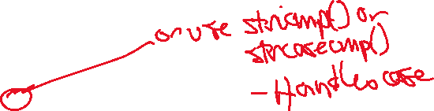

}

for (i = 0; i < TABLECONVERTS; i++)

{

if (!strcmp(convert_table[i]._legacy_inst, temp))

return i;

}

return NOMATCH;

}

/*

* Function: Translate

* -------------------

* Translate the legacy record to xm3 module record, write new record into output file and show

* error message if oper_token is missing

*

* xm3: Output file

* legacy_num: the index of insrtuction in convert_table

* oper_token: the token after instruction, oper token if instruction is not belong to ONE_INST

*

* returns: Void

*/

void Translate(FILE *xm3, int legacy_num, char *oper_token)

{

switch (convert_table[legacy_num]._type)

{



case ONE_INST:

fprintf(xm3, "%s %s", convert_table[legacy_num]._new_inst,

convert_table[legacy_num]._new_oper);

if (strcmp(oper_token, NOMORE) != 0)

fprintf(xm3, " %s", oper_token);

break;

case TWO_INST:

fprintf(xm3, "%s %s\n", convert_table[legacy_num]._new_inst,

convert_table[legacy_num]._new_oper);

if (!strcmp(oper_token, NOMORE) || oper_token[0] == ';')

fprintf(xm3, "Mssing Legacy Operand");

else

fprintf(xm3, "BRA %s", oper_token);

break;

case INST_OPER:

if (!strcmp(oper_token, NOMORE) || oper_token[0] == ';')

fprintf(xm3, "Mssing Legacy Operand");

else

fprintf(xm3, "%s %s", convert_table[legacy_num]._new_inst,

oper_token);

break;

case INST_LHOPER:

if (!strcmp(oper_token, NOMORE) || oper_token[0] == ';')

fprintf(xm3, "Mssing Legacy Operand");

else

fprintf(xm3, "%s %s,%s", convert_table[legacy_num]._new_inst,

oper_token, convert_table[legacy_num]._new_oper);

break;

case INST_RHOPER:

if (!strcmp(oper_token, NOMORE) || oper_token[0] == ';')

fprintf(xm3, "Mssing Legacy Operand");



else

fprintf(xm3, "%s %s,%s", convert_table[legacy_num]._new_inst,

convert_table[legacy_num]._new_oper, oper_token);

break;

default:

break;

}

}